**Section Overview**

**While Loops**  
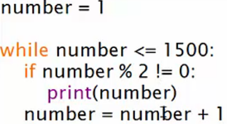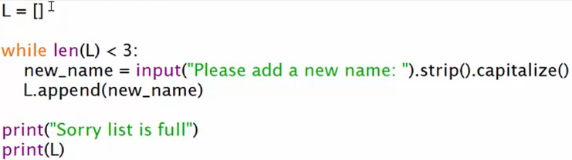

**PROJECT 6: Baby Conversation Simulator**  
**random.choice()**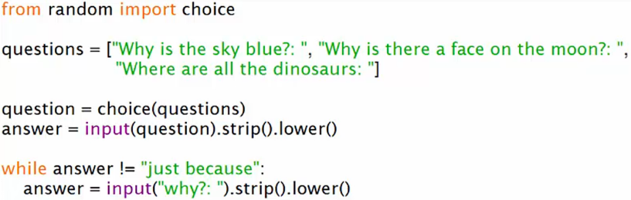

**For Loops - Part 1**  
* **The most powerful thing about FOR loops in my opinion is how well they integrate with Python’s legendary Data Structures and enable you to go through thousands of pieces of information in the blink of an eye, all with easily programmable results**.  
* For loop is made up of **a variable and an Iterable.**  
* **On each round of the for loop, the variable becomes the next value in the Iterable**.  
* This allows you to perform operations on each value in the Iterable and makes Python’s FOR loops easily expandable.  
**range(start, end, step)** => **creates an Iterable of numbers, end is not included**.  
* We can use any Iterable in the FOR loop:  
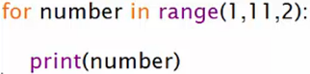  
  
  
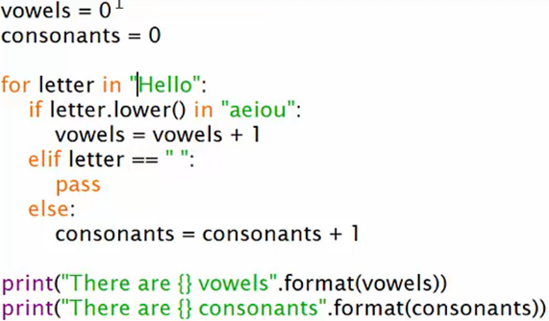  
**For Loops - Part 2**  
* **dict keys() gives us an Iterable**.  
  
  
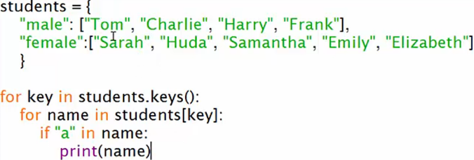  
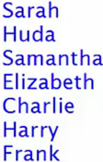

**List Comprehensions**  
**List Comprehension => a shorthand to combine variables + for loops + if statements to create a list.**  
=> **To comprehend a list**.  
  
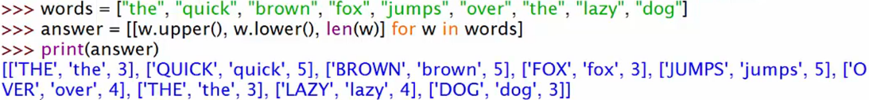  
* **You always need an outer list when doing List Comprehension**.  
* **List Comprehensions just really show off Python’s easy of use but incredible power and let that shine through. And they make creating lists super easy**.

**PROJECT 7 - Pig Latin Translator - Part 1**  
* Pig Latin is a simple joke language that makes regular words hard to understand.  
* You take the first few consonants - the first consonant cluster of a word and move those to the end of the word and than you add “ay” or “yay” depending on if it starts with a consonant.  
* Example: **gl**ove -> ove**glay**  
* Example: apple -> appleyay  
* Example: eay -> eatyay  
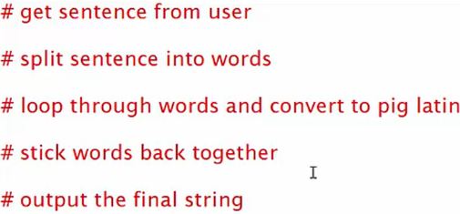

**PROJECT 7 - Pig Latin Translator - Part 2**  
**string** **split()** => **splits the string on each space and stores it in a list**  
  
**break => breaks out of a loop  
continue => skip the rest of the iteration and goes to the next iteration of a loop**  
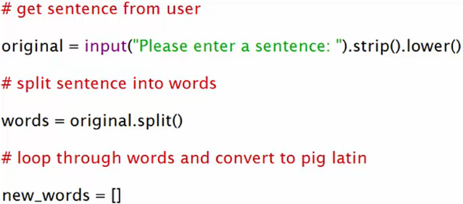

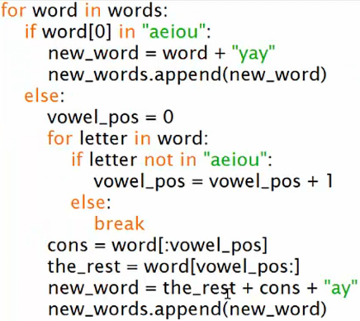   
  
**“”join() => joins each string, with what’s in the “”.**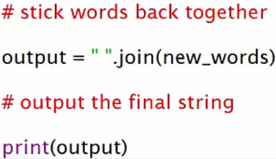  


**Section Review**